

**DEPARTMENT OF COMPUTER SCIENCE & ENGINEERING ACADEMIC YEAR 2024-2025**

**EVEN SEMESTER**



**CS23432 SOFTWARE ENGINEERING LAB LAB MANUAL**

**SECOND YEAR FOURTH SEMESTER**

**2024- 2025**

**EVEN SEMESTER**

RAJALAKSHMI ENGINEERING COLLEGE

#### An Autonomous Institution, Affiliated to Anna University, Rajalakshmi Nagar, Thandalam – 602 105



**DEPARTMENT OF COMPUTER SCIENCE AND DESIGN**

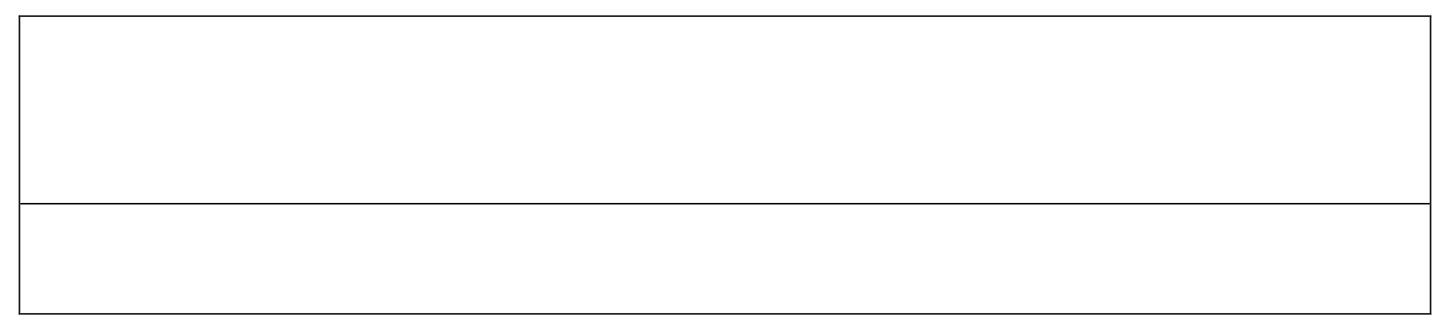

**CS23432- SOFTWARE CONSTRUCTION**

*(Regulation 2023)*

**LAB RECORD**

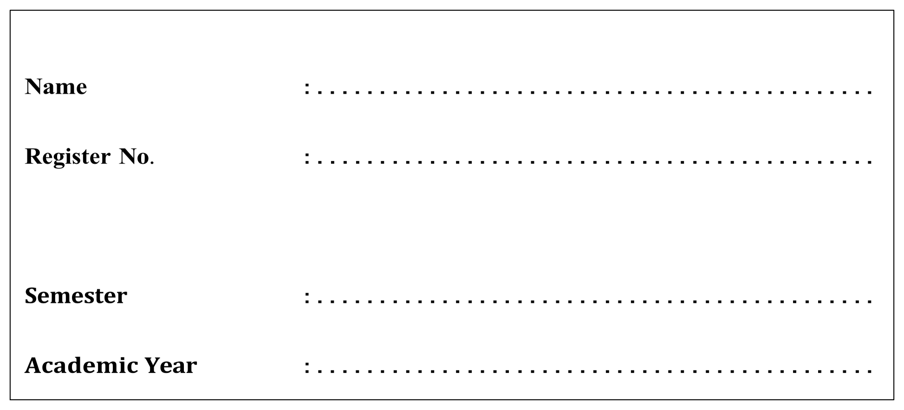

**Year/Branch/Section**

: . .**I**.**I**.**Y**. **E**. .**A**. **R**. .**/** .**C**. **S**. **D**. .**/**.**A**. . . . . . . . . . . . . . . . . . . . . . . . . . . . . . . . .

**IV SEMESTER**

**2024-2025**

|  |  |
| --- | --- |
| **Ex**  **No** | **List of Experiments** |
| 1 | Study of Azure DevOps |
| 2 | Designing Project using AGILE-SCRUM Methodology. |
| 3 | Agile Planning |
| 4 | User stories – Creation |
| 5 | Architecture Diagram Using AZURE |
| 6 | Designing Usecse and Class Diagram |
| 7 | Designing Interaction Diagrams |
| 8  9 | Design Interface  Implementation – Design a Web Page based on Scrum Methodology |
| 10  11 | Testing using Azure.  Deployment |

|  |  |
| --- | --- |
| **Requirements** | |
| Hardware | Intel i3, CPU @ 1.20GHz 1.19 GHz, 4 GB RAM,  32 Bit Operating System |
| Software | StarUML , Azure |

### LAB PLAN

**CS19442-SOFTWARE ENGINEERING LAB**

|  |  |  |  |  |
| --- | --- | --- | --- | --- |
| **Ex**  **No** | **Date** | **Topic** | **Page**  **No** | **Sign** |
| 1 |  | Study of Azure DevOps |  |  |
| 2 |  | Writing Problem Statement |  |  |
| 3 |  | Designing Project using AGILE-SCRUM Methodology by using Azure. |  |  |
| 4 |  | Agile Planning |  |  |
| 5 |  | User stories – Creation |  |  |
| 6 |  | Architecture Diagram Using AZURE |  |  |
| 7 |  | Designing Usecse Diagram using StarUML |  |  |
| 8 |  | Designing Activity Diagrams using StarUML |  |  |
| 9 |  | Designing Sequence Diagrams using StarUML |  |  |
| 10 |  | Design Class Diagram |  |  |
| 10 |  | Design User Interface |  |  |
| 11 |  | Implementation – Design a Web Page based on Scrum Methodology |  |  |
| 12 |  | Testing |  |  |
| 13 |  | Deployment |  |  |

**Course Outcomes (COs)**

**Course Name: Software Engineering**

**Course Code: CS23432**

|  |  |
| --- | --- |
| **CO 1** | Understand the software development process models. |
| **CO 2** | Determine the requirements to develop software |
| **CO 3** | Apply modeling and modeling languages to design software products |
| **CO 4** | Apply various testing techniques and to build a robust software products |
| **CO 5** | Manage Software Projects and to understand advanced engineering concepts |

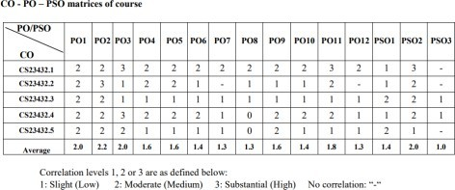

**EX NO: 1**

**Study of Azure DevOps**

**AIM:**

To study how to create an agile project in Azure DevOps environment.

**STUDY:**

Azure DevOps is a cloud-based platform by Microsoft that provides tools for DevOps practices, including CI/CD pipelines, version control, agile planning, testing, and monitoring. It supports teams in automating software development and deployment.

1. Understanding Azure DevOps

Azure DevOps consists of five key services:

* 1. Azure Repos (Version Control)

Supports Git repositories and Team Foundation Version Control (TFVC). Provides features like branching, pull requests, and code reviews.

* 1. Azure Pipelines (CI/CD)

Automates build, test, and deployment processes.

Supports multi-platform builds (Windows, Linux, macOS).

Works with Docker, Kubernetes, Terraform, and cloud providers (Azure, AWS, GCP).

* 1. Azure Boards (Agile Project Management)

Manages work using Kanban boards, Scrum boards, and dashboards. Tracks user stories, tasks, bugs, sprints, and releases.

* 1. Azure Test Plans (Testing)

Provides manual, exploratory, and automated testing. Supports test case management and tracking.

* 1. Azure Artifacts (Package Management)

Stores and manages NuGet, npm, Maven, and Python packages. Enables versioning and secure access to dependencies.

**Getting Started with Azure DevOps**

Step 1: Create an Azure DevOps Account Visit Azure DevOps.

Sign in with a Microsoft Account. Create an Organization and a Project.

Step 2: Set Up a Repository (Azure Repos) Navigate to Repos.

Choose Git or TFVC for version control. Clone the repository and push your code.

Step 3: Configure a CI/CD Pipeline (Azure Pipelines)

Go to Pipelines → New Pipeline.

Select a source code repository (Azure Repos, GitHub, etc.). Define the pipeline using YAML or the Classic Editor.

Run the pipeline to build and deploy the application.

Step 4: Manage Work with Azure Boards Navigate to Boards.

Create work items, user stories, and tasks. Organize sprints and track progress.

Step 5: Implement Testing (Azure Test Plans) Go to Test Plans.

Create and run test cases

View test results and track bugs.

**Result:**

The study was successfully completed.

**EX NO: 2**

### PROBLEM STATEMENT

**AIM:**

To prepare PROBLEM STATEMENT for your given project.

#### Problem Statement:

Weather Insights Website for Daily Planning

In a world increasingly affected by climate variability, individuals and small communities often struggle to access timely and reliable weather information tailored to their specific needs. While major weather platforms provide detailed forecasts, they are often cluttered, data-heavy, and require stable internet or mobile apps, making them less accessible for quick, user-friendly daily use.

There is a growing need for a simple, intuitive, and lightweight web-based solution that empowers users to:

1. *Fetch real-time weather data by location,*
2. *View current, hourly, and weekly forecasts,*
3. *Access weather insights for planning daily activities,and,make informed decisions based on easy- to-understand weather visuals — all without requiring technical know-how or high-bandwidth connections.*
4. *This website aims to bring accurate and actionable weather information to the fingertips of everyday users through a clean, responsive, and offline-friendly interface.*

**Result:**

The problem statement was written successfully.

### EX NO: 3

**AGILE PLANNING**

**Aim**:

To prepare an Agile Plan.

### THEORY

Agile planning is a part of the Agile methodology, which is a project management style with an incremental, iterative approach. Instead of using an in-depth plan from the start of the project—which is typically product-related—Agile leaves room for requirement changes throughout and relies on constant feedback from end users.

With Agile planning, a project is broken down into smaller, more manageable tasks with the ultimate goal of having a defined image of a project’s vision. Agile planning involves looking at different aspects of a project’s tasks and how they’ll be achieved, for example:

* Roadmaps to guide a product’s release ad schedule
  + Sprints to work on one specific group of tasks at a time
  + A feedback plan to allow teams to stay flexible and easily adapt to change

User stories, or the tasks in a project, capture user requirements from the end user’s perspective Essentially, with Agile planning, a team would decide on a set of user stories to action at any given time, using them as a guide to implement new features or functionalities in a tool. Looking at tasks as user stories is a helpful way to imagine how a customer may use a feature and helps teams prioritize work and focus on delivering value first.

* + Steps in Agile planning process
    1. Define vision
    2. Set clear expectations on goals
    3. Define and break down the product roadmap
    4. Create tasks based on user stories
    5. Populate product backlog
    6. Plan iterations and estimate effort
    7. Conduct daily stand-ups
    8. Monitor and adapt

#### Result:

Thus the Agile plan was completed successfully.

### EX NO: 4

**CREATE USER STORIES**

#### Aim:

To create User Stories

### THEORY

A user story is an informal, general explanation of a software feature written from the perspective of the end user. Its purpose is to articulate how a software feature will provide value to the customer.

User story template

#### "As a [role], I [want to], [so that]."

**Procedure:**

1. Open your web browser and go to the Azure website: *https:// azure.microsoft.com/en-in* Sign in using your Microsoft account credentials. If you don't have an account, you'll need to create one.
2. If you don’t have a Microsoft account, you can sign up for

*https://signup.live.com/?lic=1*

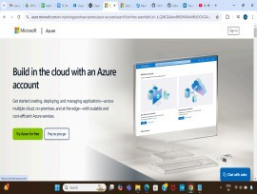

1. Azure home page

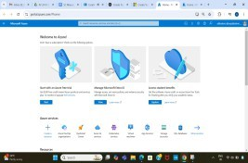

1. Open DevOps environment in the Azure platform by typing Azure DevOps Organizations in the search bar.

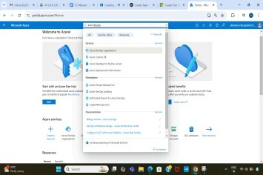

1. 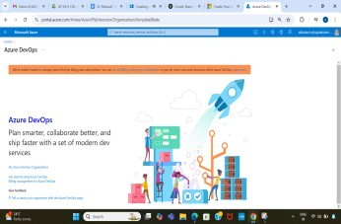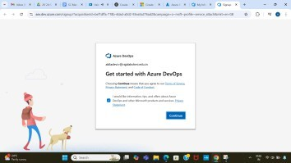Click on the My Azure DevOps Organization link and create an organization and you should be taken to the Azure DevOps Organization Home page.

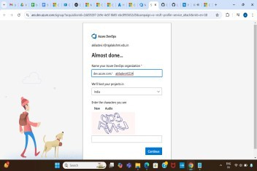

1. Create the First Project in Your Organization

After the organization is set up, you’ll need to create your first **project**. This is where you'll begin to manage code, pipelines, work items, and more.

* 1. On the organization’s **Home page**, click on the **New Project** button. ii. Enter the project name, description, and visibility options:
     + **Name**: Choose a name for the project (e.g., LMS).
     + **Description**: Optionally, add a description to provide more context about the project.
       - **Visibility**: Choose whether you want the project to be **Private**

(accessible only to those invited) or **Public** (accessible to anyone).

iii. Once you’ve filled out the details, click **Create** to set up your first project.

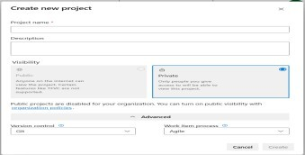

1. Once logged in, ensure you are in the correct organization. If you're part of multiple organizations, you can switch between them from the top left corner (next to your user profile). Click on the Organization name, and you should be taken to the Azure DevOps Organization Home page.

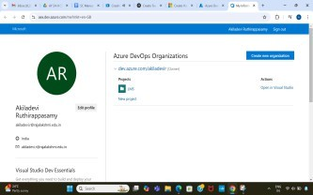

1. Project dashboard

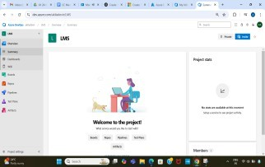

1. To manage user stories
2. From the **left-hand navigation menu**, click on **Boards**. This will take you to the main **Boards** page, where you can manage work items, backlogs, and sprints.
3. On the **work items** page, you'll see the option to **Add a work item** at the top. Alternatively, you can find a **+** button or **Add New Work Item** depending on the view you're in. From the **Add a work item** dropdown, select **User Story**. This will open a form to enter details for the new User Story.

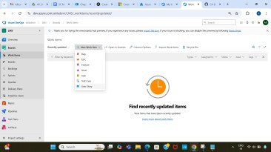

1. Fill in User Story Details

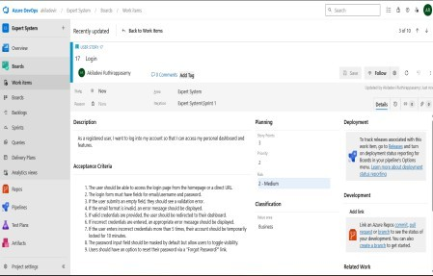

**Result:**

The user story was written successfully.

### EX NO: 5

**SEQUENCE DIAGRAM**

#### Aim:

To design a Sequence Diagram by using Mermaid.js

### THEORY:

A Sequence Diagram is a key component of Unified Modelling Language (UML) used to visualize the interaction between objects in a sequential order. It focuses on how objects communicate with each other over time, making it an essential tool for modelling dynamic behaviour in a system.

#### Procedure:

1. Open a project in Azure DevOps Organisations.
2. 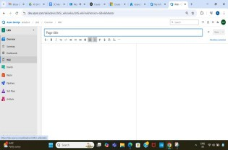To design select wiki from menu
3. Write code for drawing sequence diagram and save the code.

@startuml

actor User

participant "Mobile App" as App

participant "Backend Server" as Server

participant "Database" as DB

participant "Notification Service" as Notif

== User Login ==

User -> App : Launches app

App -> Server : Send login credentials

Server -> DB : Verify user credentials

DB --> Server : Return user data

Server --> App : Authentication success

App --> User : Show chat UI

== Sending Message ==

User -> App : Types and sends message

App -> Server : Send message content

Server -> DB : Store message

Server -> Notif : Notify recipient

Notif --> Server : Delivery success

Server --> App : Message sent confirmation

== Receiving Message ==

Server -> App : Push new message to recipient

App --> User : Display incoming message

@enduml:::

# Explanation:

## **1. User Login Flow**

## **Actors Involved:**

## **User** – The person using the app.

## **Mobile App** – The client application installed on the user's device.

## **Backend Server** – The server that handles authentication and business logic.

## **Database** – Stores user credentials and data.

## **Steps:**

## **User → App**: The user opens the messaging app.

## **App → Server**: The app sends login credentials (e.g., username & password) to the server.

## **Server → DB**: The server checks the credentials against the database.

## **DB → Server**: If valid, the database returns the user’s account info.

## **Server → App**: The server confirms successful login.

## **App → User**: The app then displays the main chat interface to the user.

## ✅ *This ensures only authenticated users can access the app.*

## **📘 2. Sending a Message**

## **Actors Involved:**

## **User**

## **Mobile App**

## **Backend Server**

## **Database**

## **Notification Service** – Used to deliver messages to other users, especially when they are offline.

## **Steps:**

## **User → App**: The user types a message and hits “Send.”

## **App → Server**: The app sends the message content to the server.

## **Server → DB**: The server stores the message in the database for persistence.

## **Server → Notif**: The server then notifies the recipient through a push notification service (e.g., Firebase, APNs).

## **Notif → Server**: Confirms the notification has been delivered.

## **Server → App**: The server tells the sender’s app that the message was successfully sent.

## ✅ *This ensures messages are stored and reliably delivered to the recipient.*

## **📘 3. Receiving a Message**

## **Actors Involved:**

## **Server**

## **Mobile App**

## **User**

## **Steps:**

## **Server → App**: When a new message arrives, the server pushes it to the recipient's app.

## **App → User**: The app displays the message to the user in the chat UI.

## ✅ *Users get real-time updates when new messages arrive.*

## **📝 Summary**

## This **sequence diagram** models the lifecycle of key messaging actions:

## Secure **user login**

## Reliable **message sending and storage**

## Real-time **message receiving**

## Each component plays a role in **delivering a seamless messaging experience**, ensuring both reliability and security.

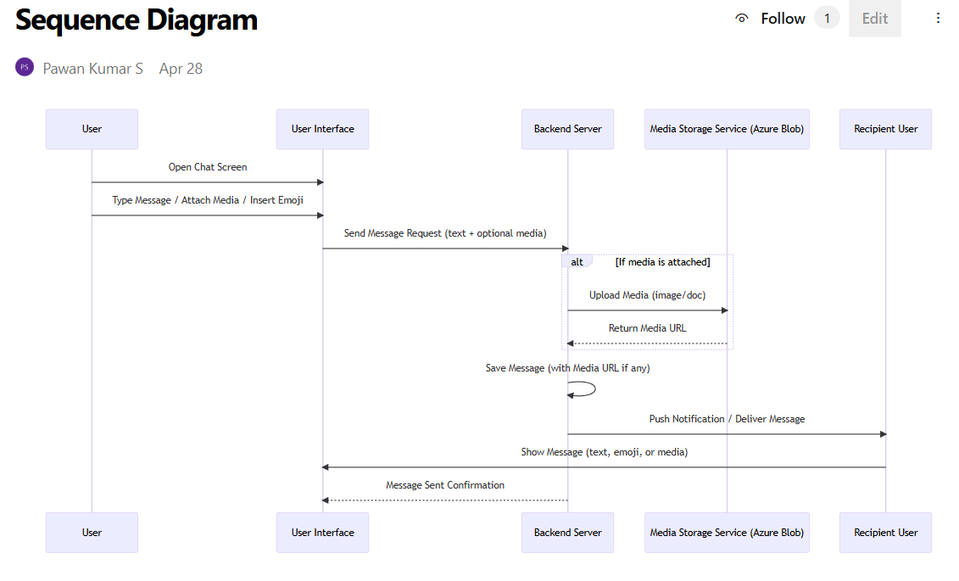

**Result:**

The sequence diagram was drawn successfully.

**EX NO. 6**

**CLASS DIAGRAM**

**AIM :-**

To draw a sample class diagram for your project or system.

### THEORY

A UML class diagram is a visual tool that represents the structure of a system by showing its classes, attributes, methods, and the relationships between them.

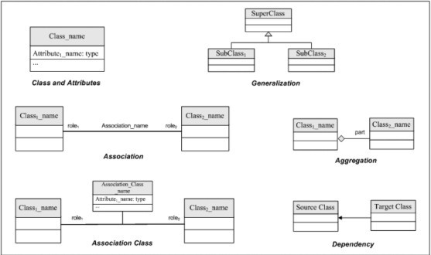

Notations in class diagram

**Procedure:**

1. Open a project in Azure DevOps Organisations.
2. To design select wiki from menu

**Code**:

@startuml

class User {

+userId: String

+username: String

+email: String

+passwordHash: String

+login(): boolean

+logout(): void

+sendMessage(message: Message): void

+receiveMessage(message: Message): void

}

class Message {

+messageId: String

+content: String

+timestamp: DateTime

+sender: User

+recipient: User

+isRead: boolean

+markAsRead(): void

}

class Chat {

+chatId: String

+participants: List<User>

+messages: List<Message>

+addParticipant(user: User): void

+removeParticipant(user: User): void

+sendMessage(message: Message): void

}

class Notification {

+notificationId: String

+recipient: User

+message: Message

+sendNotification(): void

}

User "1" -- "0..*" Message : sends >

User "1" -- "0..*" Message : receives >

Chat "1" *-- "0..*" User : participants >

Chat "1" *-- "0..*" Message : contains >

Notification "1" --> "1" User : recipient >

Notification "1" --> "1" Message : related to >

@enduml

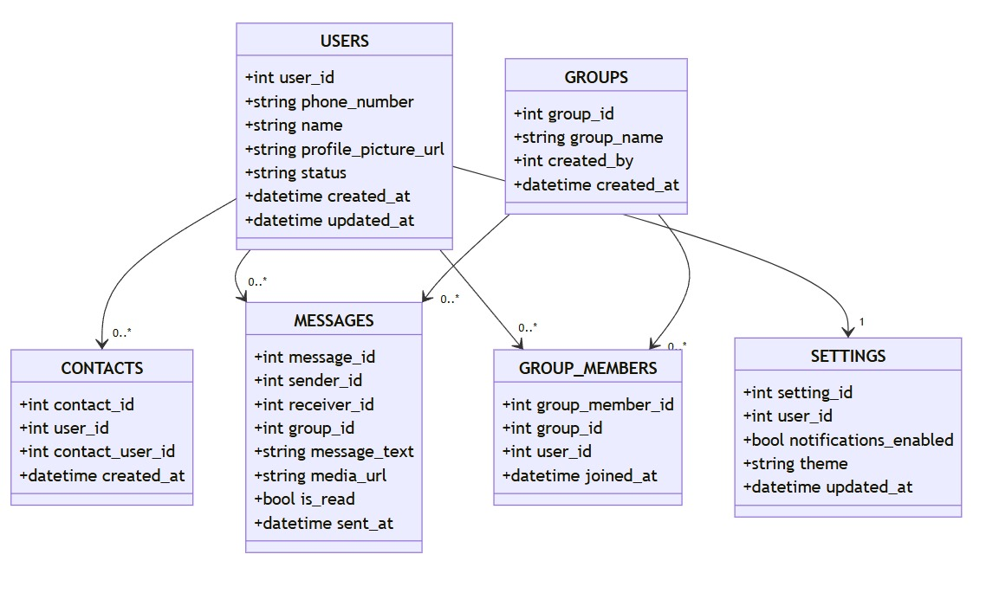

1. Write code for drawing class diagram and save the cod

#### Result:

The use case diagram was designed successfully.

### EX NO: 7

**USECASE DIAGRAM**

**Aim**:

Steps to draw the Use Case Diagram using draw.io

#### Theory:

* UCD shows the relationships among actors and use cases within a system which Provide an overview of all or part of the usage requirements for a system or organization in the form of an essential model or a business model and communicate the scope of a development project
  + **Use Cases**
  + **Actors**
  + **Relationships**
  + **System Boundary Boxes**

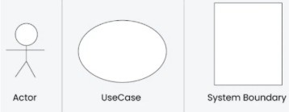

**Procedure**

**Step 1**: Create the Use Case Diagram in Draw.io

* + - Open Draw.io (diagrams.net).
    - Click "Create New Diagram" and select "Blank" or "UML Use Case" template.
    - Add Actors (Users, Admins, External Systems) from the UML section. ● Add Use Cases (Functionalities) using ellipses.
    - Connect Actors to Use Cases with lines (solid for direct interaction, dashed for

<<include>> and <<extend>>).

* + - * Save the diagram as .drawio or export as PNG/JPG/SVG.

**Step 2**: Upload the Diagram to Azure DevOps Option 1: Add to Azure DevOps Wiki

* + - * + Open Azure DevOps and go to your project.
        + Navigate to Wiki (Project > Wiki).
        + Click "Edit Page" or create a new page.

Drag & Drop the exported PNG/JPG image.

* + - * + Use Markdown to embed the diagram:

![Use Case Diagram](attachments/use_case_diagram.png)

Option 2: Attach to Work Items in Azure Boards

* Open Azure DevOps → Navigate to Boards (Project > Boards).
* Select a User Story, Task, or Feature.
  + Click "Attachments" → Upload your Use Case Diagram.
  + Add comments or descriptions to explain the use case.

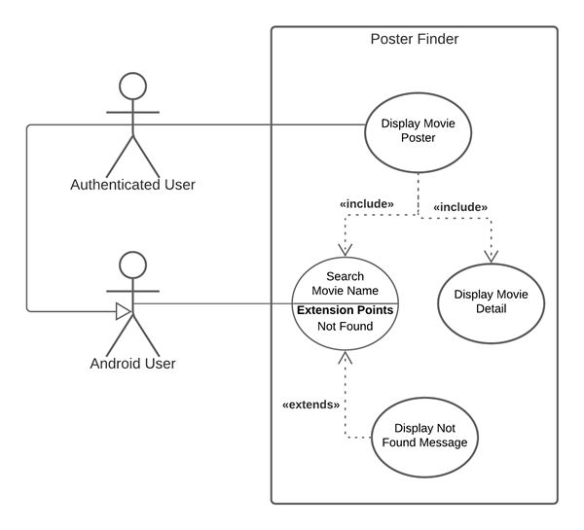

#### Result:

The use case diagram was designed successfully

**EX NO. 8**

**ACTIVITY DIAGRAM**

**AIM :-**

To draw a sample activity diagram for your project or system.

### THEORY

Activity diagrams are an essential part of the Unified Modelling Language (UML) that help visualize workflows, processes, or activities within a system. They depict how different actions are connected and how a system moves from one state to another.

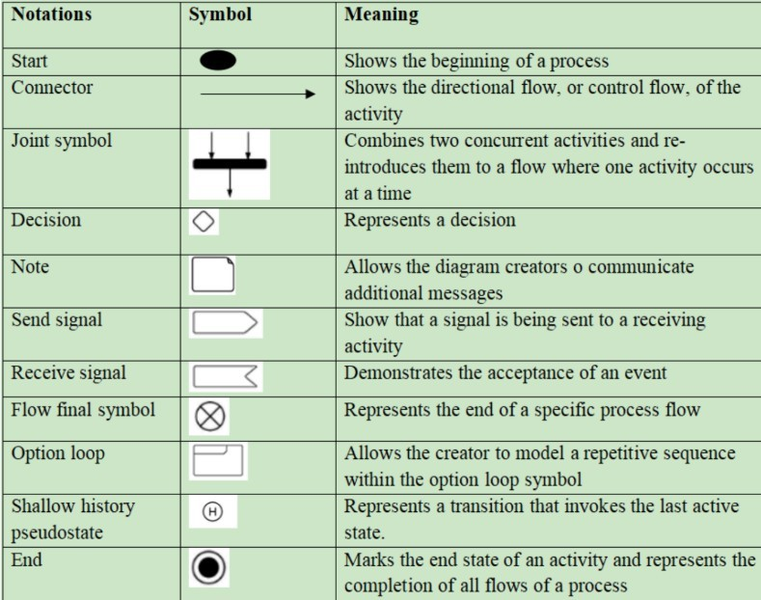

#### Procedure

1. Draw diagram in draw.io
2. Upload the diagram in Azure DevOps wiki

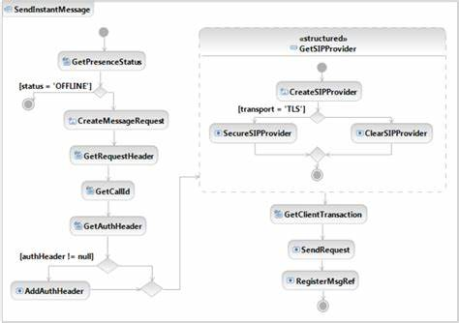

#### Result:

The activity diagram was designed successfully

### EX NO. 9

#### Aim:

### ARCHITECTURE DIAGRAM

Steps to draw the Architecture Diagram using draw.io.

#### Theory:

An architectural diagram is a visual representation that maps out the physical implementation for components of a software system. It shows the general structure of the software system and the associations, limitations, and boundaries between each element.

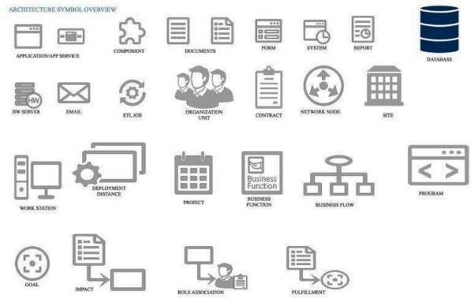

#### Procedure:

1. Draw diagram in draw.io
2. Upload the diagram in Azure DevOps wiki

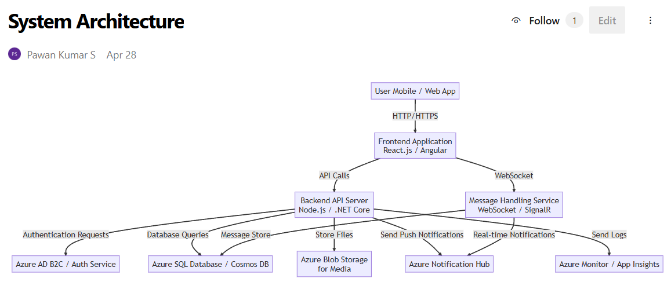

#### Result:

The architecture diagram was designed successfully

### EX NO. 10

#### Aim:

### USER INTERFACE

Design User Interface for the given project

**Code:**

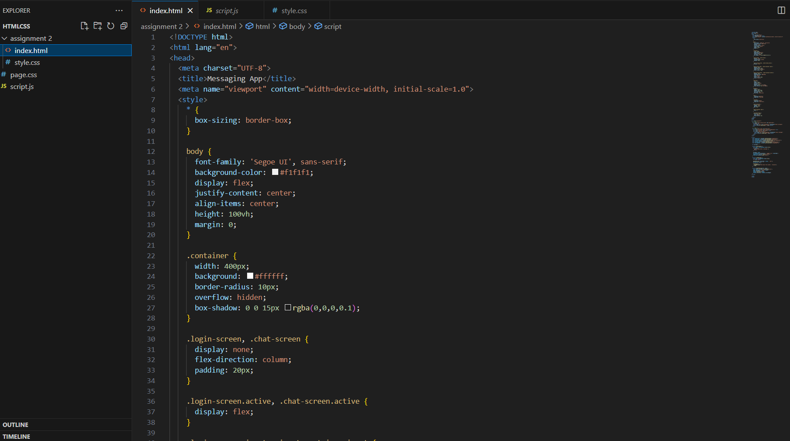

**Output:**

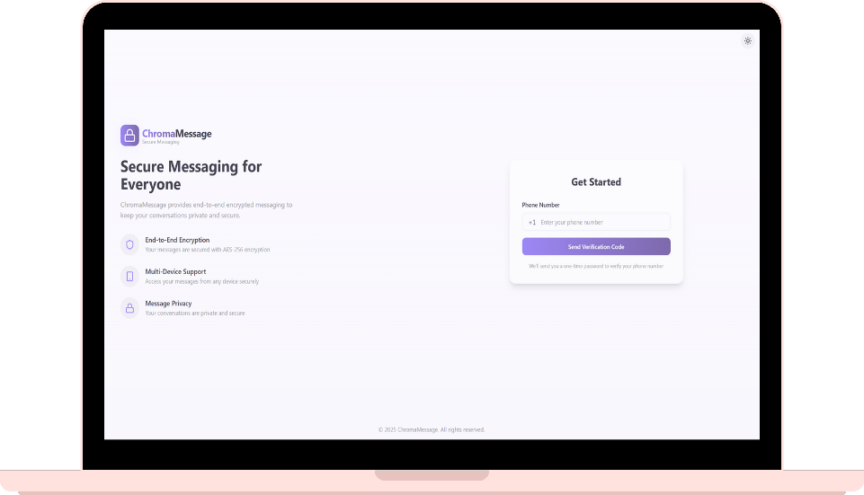

**Result:**

The UI was designed successfully.

### EX NO. 11

#### Aim:

### IMPLEMENTATION

To implement the given project based on Agile Methodology.

#### Procedure:

Step 1: Set Up an Azure DevOps Project

* Log in to Azure DevOps.
* Click "New Project" → Enter project name → Click "Create".
* Inside the project, navigate to "Repos" to store the code.

Step 2: Add Your Web Application Code

* Navigate to Repos → Click "Clone" to get the Git URL.
* Open Visual Studio Code / Terminal and run: git clone <repo_url>

cd <repo_folder>

* Add web application code (HTML, CSS, JavaScript, React, Angular, or backend like Node.js, .NET, Python, etc.).
* Commit & push:

git add .

git commit -m "Initial commit" git push origin main

Step 3: Set Up Build Pipeline (CI/CD - Continuous Integration)

* Navigate to Pipelines → Click "New Pipeline".
* Select Git Repository (Azure Repos, GitHub, or Bitbucket).
* Choose Starter Pipeline or a pre-configured template for your framework.
* Modify the azure-pipelines.yml file (Example for a Node.js app):

trigger:

- main

pool:

vmImage: 'ubuntu-latest'

steps:

* task: UseNode@1 inputs:

version: '16.x'

* script: npm install

displayName: 'Install dependencies'

* script: npm run build displayName: 'Build application'
* task: PublishBuildArtifacts@1 inputs:

pathToPublish: 'dist'

artifactName: 'drop'

Click "Save and Run" → The pipeline will start building app.

Step 4: Set Up Release Pipeline (CD - Continuous Deployment) ● Go to Releases → Click "New Release Pipeline".

* Select Azure App Service or Virtual Machines (VMs) for deployment.
* Add an artifact (from the build pipeline).
* Configure deployment stages (Dev, QA, Production).
* Click "Deploy" to push your web app to Azure.

#### Result

Thus the application was successfully implemented.